**PROJECT NAME :- AMAZON**

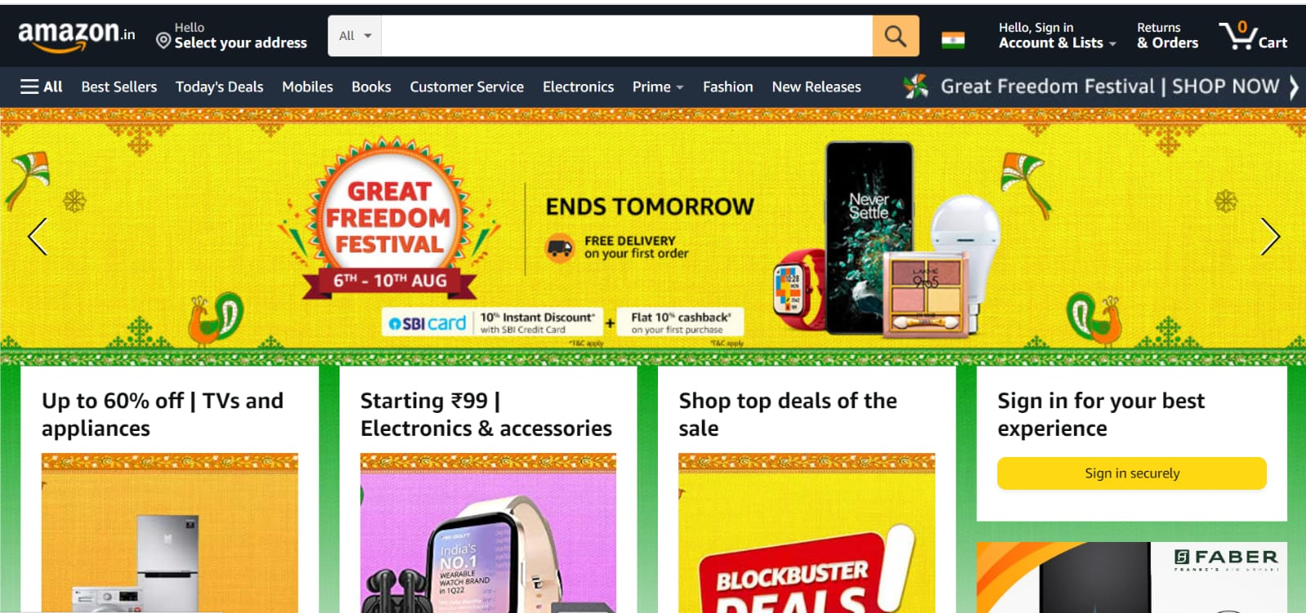

**OVERVIEW :-** The E-commerce website where users buy the clothes ,shoes ,house hold items ,electronic gadgets etc.

**1. HOME PAGE:-**

* Logo
* Search bar
* Add to cart
* Navigation bar:

1.Best sellers

2.Mobiles

3.Book

4. Electronics

5. Fashion

6. New releases

* Any festival or any offer banner
* Trending (images)
* Footer:

1.Back to top

2.Logo

3.Brief description of company

4. Contact us

5. Helplines

6. Social media handle icons

7. Link to mobile app

**2.MAIN PAGE :-**

* Filters:

{Brands , Customer review , New arrivals item Condition , price , discount , seller}

* Images of the chosen product with details like :

{Brands , Products , Name , Price, Discount, Offers}

* On Clicking The Image :

{Multiple images of the product will appear from different angles , zoom in , zoom out }

* Product Description :

{Brand , Product Name , Price, Discount, Product Details, Size Chart , Delivery Options, Material and Care, Ratings, Customer Reviews}

* Below The Product Page :

{Related Products}

**3.PAYMENT PAGE :-**

* Address Selection
* Payment Method :

{Cash On Delivery, Credit/Debit Card, Net-Banking, EMI, UPI(Phonepe, Paytm, Gpay)}